Agent Charge Back Pseudocode
The Date From and Date To inputs from the user on the face of the dashboard are referenced further below as the inputted Begin Date and End Date.
A temporary table called #ConsolidatedIDs is created with all member_id and HICN/MBI associations. Using the dbo.broker_compenstation table from the MedicareEligibility database the entries with the maximum file date that also do not have a Contract Number of H1977 are stored in another temporary table named #broker_compensation. The #ConsolidatedIDs table is joined on this new temporary table on matching HICNs and brings member_ids to each of the entries of the #broker_compensation.
The main data pull of this report comes from the eligibility table, member table, #broker_compensation temporary table, and the supplemental info table for the member supplemental info; all tables are joined on member_id. The report pulls:
- Policy Number
  - eligibility_ud from the eligibility table
- Beneficiary Last and First Name
  - member last and first name from the member table
- Eff Date
  - the most recent Enrollment Effective Start Date for the member from the #broker_compensation table
- Term Date
  - eligibility term date from the eligibility table
- Cycle Year
  - Cycle Year As Of Report Generate Date from the #broker_compensation table
- Member Months
  - value found from the Member Months calculation below
- Commission Amount
  - value found from the Commission Amount calculation below
- Agent
  - Agent Last and First name found from the dbo.Agent_info table which is joined on the name found in Field 43 of the member’s supplemental info
- Agency Name
  - name comes from the Agent_info table joined on the criteria above
- Rapidly Disenrolled
  - If the month difference between the most recent Enrollment Effective Start Date from the #broker_compensation table and the eligibility term date plus one day is less than 3 months
    - ‘Yes’
  - Else
    - null
- Termination Reason
  - termination reason found using the termination_reason_id from the eligibility table
- Date Span
  - the concatenation of the inputted Begin Date and End Date
The following conditions must be met for data to get pulled into this report:
- The Employer Group from the eligibility table must start with ‘H2161’
- Field 43 on the member’s supplemental info is not null
- The member’s eligibility term date is between the inputted Begin Date and End Date
- The Enrollment Effective Start Date from the #broker_compensation table must be before the eligibility term date
- The Termination Reason is not ‘PREMIUM CHANGE’ or is null
- The Agency name selected in the dropdown list exists in the dbo.Agent_info table
The Member Months calculation:
Member Months is set equal to:
- When the eligibility term date is not null
        - if a member was enrolled during the selected span (the ‘from date’ and ‘to date’ the user selected on dashboard) and not termed until after the end of the year:
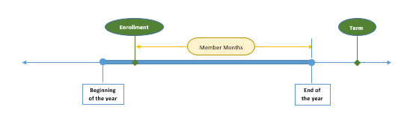
          - then calculate member months to be equal the number of months between the EnrollmentEffectiveStartDate (broker compensation table) and the end of the selected year.

        - else when a member has been enrolled for more than 12 months (enrolled before beginning of year and termed after the end of the year)
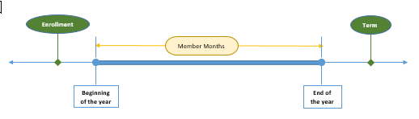
          - return the number 12 (total months of whole year)
        - else when a member’s EnrollmentEffectiveStartDate occurred in the year prior to their eligibility term date
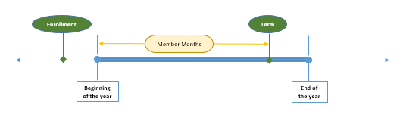
          - return the number of months between the beginning of the year and the member’s eligibility term date month that falls within the span selected.
- else return the number of months between the members EnrollmentEffectiveStartDate and the member’s eligibility term date as they fall within the selected span.
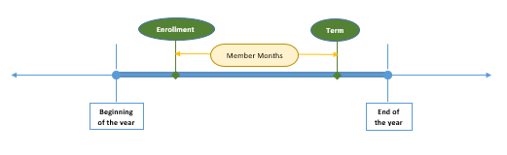
- If the eligibility term date is null
  - if a member’s EnrollmentEffectiveStartDate is greater than the beginning of the year
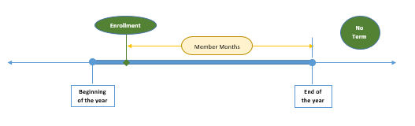
    - then return the number of months between their EnrollmentEffectiveStartdate and the end of the year based upon selected span Else
  - else, the member was enrolled at or before the beginning of the year
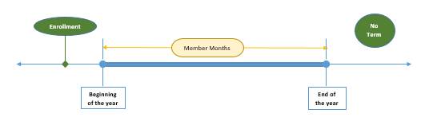
    - return the number 12 (total months of whole year)
The Commission Amount calculation uses the Monthly Commission Amount found for each Year and specific month span, this is done by finding the initial commission amount if the Cycle Years = 1 or the renewal commission amount if the Cycle Years does not equal 1 from the dbo.poa_PlanYear table in which the year on the table is the Year of the Begin Date and the Month of the Begin Date fits in one of the monthly spans on the table. This original commission amount is divided by twelve to the get the monthly rate. This monthly rate is then used in the following calculation to find the agent’s commission amount:
- When the Cycle Years as of Report Generate Date = 1 and the Year of the Begin Date is before 2018
  - Monthly Rate multiplied by the number of months the member was not eligible for during the year and multiplied by -1
- When the Cycle Years = 1 and the Year of the Begin Date is equal to or greater than 2018
  - Monthly Rate multiplied by -1
- When the Cycle Years does not equal 1 and the Year of the Begin Date is equal to or greater than 2018
  - Monthly Rate multiplied by -1
- Else
  - Monthly Rate multiplied by number of months the member was not eligible for during the year and multiplied by -1
The rates are multiplied by a negative one because the commission amount is a charge back in this report so the amount will be a negative value. Below is what the dbo.poa_PlanYear table looks like as of 9/12/2019.
